DATA FLOW DIAGRAM

Level 0 DFD for Supermarket Management System

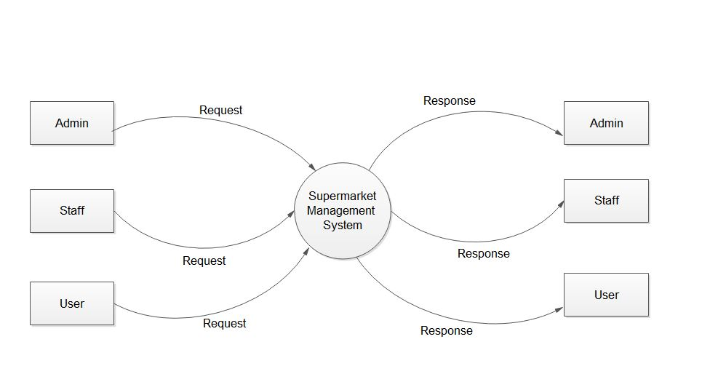

Level 1 DFD for Admin

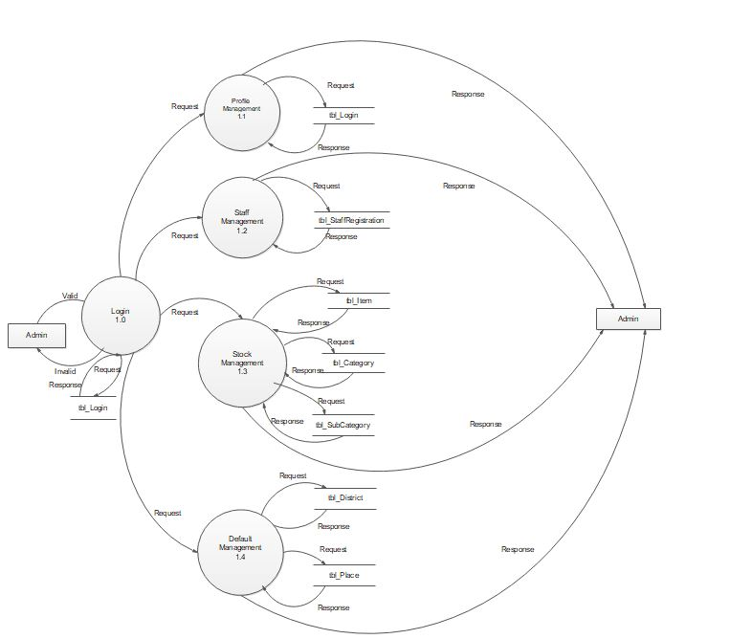

Level 1 DFD for Staff

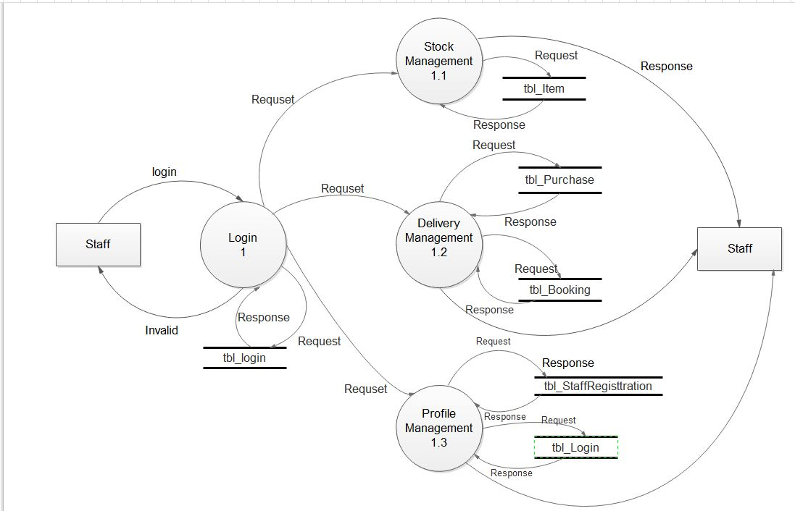

Level 1 DFD for User

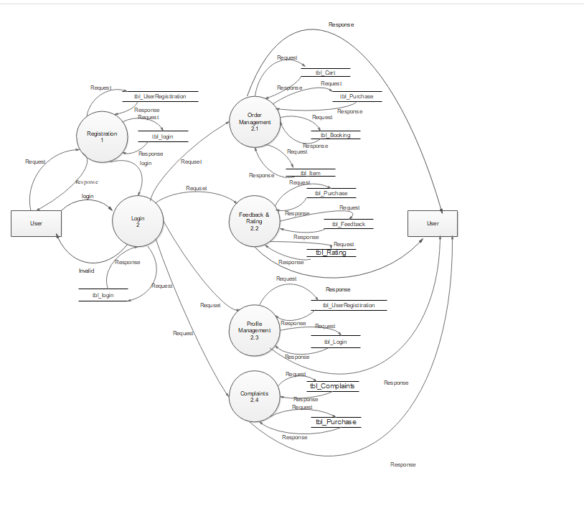

Level 2 DFD for Order Management – User

